**Difference between Arguments and Parameter?**

**Argument**

* An argument is a **value passed to a function** when the function is called.
* Whenever any function is called during the execution of the program there are some values passed with the function. These values are called arguments

|  |
| --- |
| **public** **class** Example {    **public** **static** **int** multiply(**int** a, **int** b)      {  **return** a * b;      }    **public** **static** **void** main(String[] args)      {  **int** x = 2;  **int** y = 5;            // the variables x and y are arguments  **int** product = multiply(x, y); |

**Parameter**

* A parameter is a **variable** used to define a particular value during **a function definition.**

**public** **class** Example {

    // the variables a and b are parameters

**public** **static** **int** multiply(**int** a, **int** b)

    {

**return** a * b;

    }

Example with both Argument and parameter

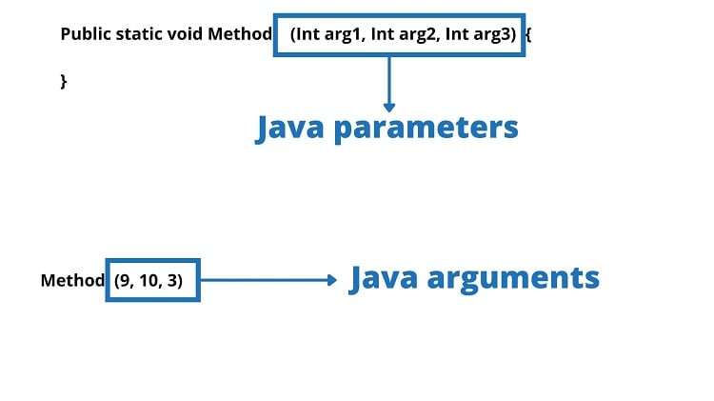

Notice that the Parameter is variable in the declaration of the function and the Argument is the actual value of this variable that gets passed to function.